Year 3 Number Knowledge – Autumn 1
Each term, your child will focus on two areas to help them with their understanding of number. We would like you to choose one of the following activities to complete at home each week.

Counting: Counting in 10s

Count aloud in multiples of 10 from zero. You could try one of the following to help make it more fun:  - Say a multiple of 10 whilst going up or down the stairs  - Throw a ball and say a multiple of 10 each time the ball is caught  - Jump from one side of the room to another whilst counting in 10s  - Counting in 10s using different voices | Write multiples of 10 to at least 100 on slips of paper (e.g. 10, 20, 30…). Mix them up and then sort them into the correct order. You could make it more fun by getting someone else to hide the multiples of 10 for you to find.
Get a family member or friend to write down a 3-digit number. You must read the number aloud and then say what number is 10 more and 10 less than the original number.  E.g.  846  Ten less than 846 is 836.  Ten more than 846 is 856. | Here are some online games you could play:  https://www.studyzone.tv/game152-code7c4d9b219ae1d1eb339330f0d7e715c5  https://ictgames.com/mobilePage/duckShoot/index.html  https://ictgames.com/mobilePage/nuttyNumbers/index.html  CHALLENGE: Create your own game to help others learn to count in 10s.

Multiplication tables and related division facts: 10 and 5 x table

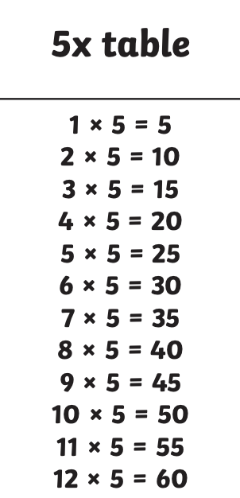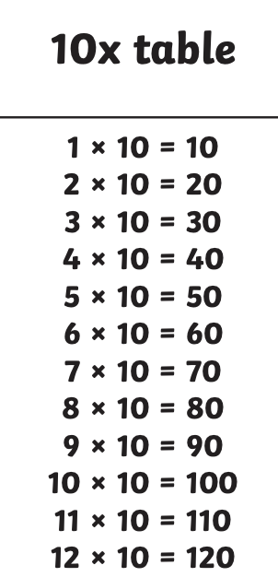 | Play on TTRockstars.  https://ttrockstars.com/  If you are having problems logging in, please speak to us and we can help.
Get a pack of playing cards (or write the numbers 1 to 12 on scrap pieces of paper). Turn over a card one at a time and multiply the number on the card by either 10 or 5. Challenge yourself to see how many you can get correct in 1 minute – can you beat your score the next time?  E.g.  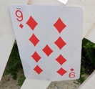  X 5 = 45 | Write out all the answers to the times table. You could do this on slips of paper and put them around the room, write them on a big piece of paper or write them outside using chalk. Get a family member or friend to call out a calculation. You have to touch the correct answer as quick as you can.  CHALLENGE: move the answers further apart.  SUPPORT: keep the answers in the correct order.

