Year 3 and 4 homework; due in Tuesday 15th September 2020
Project
We have been using atlases and maps to help us with our learning about the countries and their capital cities of the British Isles. Think of three other countries from around the world and research their capital cities.
Challenge – locate those countries on a world map.
Reading
Make sure you are reading a book you are enjoying and want to read. To help your reading further, you should be reading a minimum of four times a week. Write a comment in your reading record. You could try thinking aloud to help you make sense of what you read.
Spelling
This week, we would like you to write each of your spelling words in a sentence. You can choose whether you do
Mild | Spicy | Hot
any | should | because
there | does | every
one | our | people
are | could | which

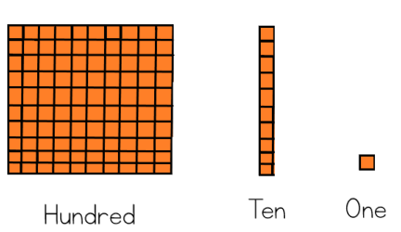
Maths
Use dienes to represent the following numbers

Mild | Spicy | Hot
11, 12, 13, 14, 15 | 37, 25, 105, 94, 73 | 124, 147, 238, 854, 675

Challenge – how many different ways can you use dienes to represent 120.

