Year 3 and 4 homework; due in Wednesday 3rd March 2020
English -
We have sent home the poems we are going to be performing at next week World Book Day Performance. Please continue to learn at home;
Year 3 - Vegan Delight by Benjamin Zephaniah
Year 4 - From a Railway Carriage by Robert Louis Stevenson
Reading
Make sure you are reading a book you are enjoying and want to read. To help your reading further, you should be reading a minimum of four times a week. Write a comment in your reading record. You could try thinking aloud to help you make sense of what you read.
Sadly, not all the children are doing this and this and needs to improve. The comment can be written by the child or by an adult. The records are checked daily.
Science
Look for examples of pushes and pulls around your home - either draw them or take a photo and label the image.
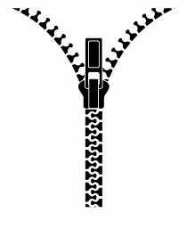The zip is being pulled up to close the coat.
Maths
Mrs Di Giorno’s group. We have begun looking at the grid method for multiplying. Use the example to help you
x | 10 | 4
3 | 30 | 12

x | 10 | 4
5

x | 10 | 4
4

x | 10 | 4
7

x | 10 | 4
6

x | 10 | 4
8

