Writing
We engage children with the writing process by using a wide variety of films and texts. The children undertake a series of lessons that develop the writing process.

The writing process is directly linked to our reading provision and is displayed on our English working walls Children are encouraged to make use of support available to enhance their independent writing skills. The children help to develop a set of success criteria/writing toolkit during each unit which will enable them to assess their own writing. We make use of InnovatEducation’s genre progression documents to support teachers in their pitch.
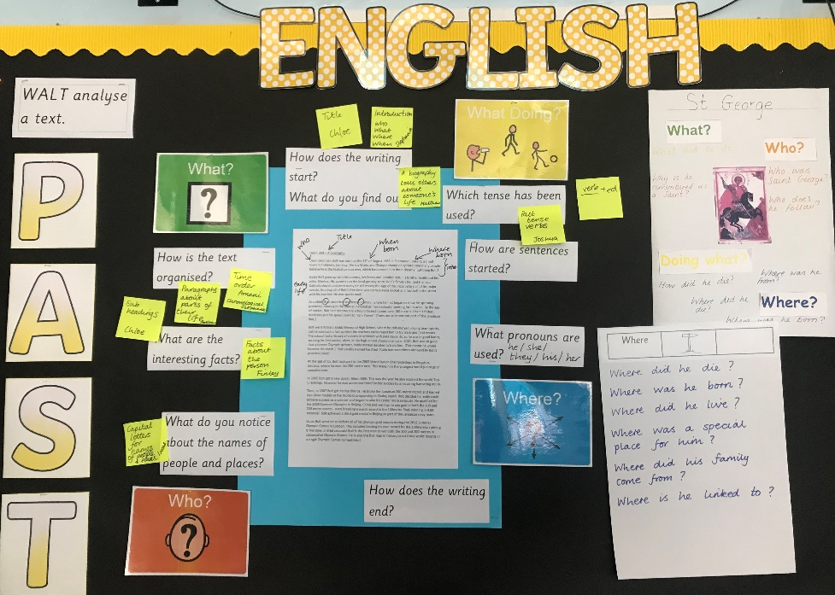

The writing foci for each term will be linked to the long-term planning document and covers a range of age appropriate genres during a child’s time within each phase. Each phase selects one key genre as the focus for the half term and then supports this with other genres of writing to explore the project/text.

Genre coverage for 2021/2022
 | Year 1 | Year 2 | LKS2 | UKS2
Autumn 1 Featuring Writing Wrongs | What a Waste  Writing to inform.  Posters to encourage recycling | What a Waste  Writing to inform.  Leaflets to encourage recycling | Fantastically great women who saved the planet.  Non Chronological reports about an environmental campaigner.  Oliver Twist  Exploring childhood in Victorian times and writing about the right to a childhood including going to school. Descriptive writing and letters about an issue. | Curiosity - story of the Mars rover. Explanation texts linked to the Mars Rover.  Persuasive Letter writing about the issue of imprisonment using Amnesty’s Power of the Pen project.  The Highwayman - Narrative poetry.
Autumn 2 | Sulwe  Letter writing to Sulwe  The Christmas Book  Retelling of the Christmas Story | Martin’s Big Words  Speech inspired by MLK.  Non chronological report on MLK  The Christmas Book  Retelling of the Christmas Story | Arthur and the Golden Rope  Norse Myth | Beowulf  Descriptive writing  Odd and the Frost Giants  Retelling - alternative perspective
Spring 1 | Kenya’s Song  Poems, songs and lyrics  The Town Mouse and The Country Mouse  Setting and character descriptions  Banbury: History Guide  Information writing comparing Banbury and Tackley | A Likkle Miss Lou: How Jamaican Poet Louise Bennett Coverley Found Her Voice  Poems, songs and lyrics  The Town Mouse and The Country Mouse  Narrative - Town Mouse and Country Mouse adaptation  Banbury: History Guide  Information writing comparing Banbury and Tackley | River Story  Narrative poetry | The Promise  Narrative writing linked to lifecycles  Non Chronological reports linked to lifecycles of animals for an information book for younger children.
Spring 2 | How do bridges not fall down  Instructional writing  DT Evaluation | How do bridges not fall down by Jennifer Shand  Explanations  (Based on DT bridge project)  Setting descriptions of bridge landscapes around the UK. | Canada: A Benjamin Blog and His Inquisitive Dog Guide  Travel writing  Persuasive travel brochure | The extraordinary life of Greta Thunberg  Biography  Environmental poetry
Summer 1 | Dear Zoo  Narrative writing  Adaptation of Dear Zoo | The Rainbow Bird  Narrative writing  Adaptation of ‘How the… | Leon and the place between - Narrative adventure story  Until I met Dudley  Explanation text | The Invention of Hugo Cabret  Diary entry  Flashback narrative  Journalistic writing
Summer 2 | Queen  Invitations, menus, posters for Jubilee Celebration.  A is for Australia Persuasive writing, labels and captions. Penpal letter writing to friends from Commonwealth countries. | Queen  Invitations, menus, posters for Jubilee Celebration.  This is South Africa Persuasive writing, labels and captions. Penpal letter writing to friends from Commonwealth countries | Weslandia  Character descriptions and narrative retelling NCR | Arabian Nights  Narrative writing

Grammar, Punctuation and Spelling
To support teaching and learning in Grammar and Punctuation we use a variety of resources to meet the needs of National Curriculum. The subject is taught discreetly and within English lessons. Spelling is taught weekly and the words are sent home for children to practise. The spelling patterns are revisited and built upon throughout a child’s time a St Mary’s. The children in Upper Key Stage 2 use the spellings in weekly dictation sentences. The children self-select the spellings they learn but can seek guidance from their class teacher. In 2021 -2022, Year 6 are trialling The Spelling Book by Jane Considine.

Fine Motor Skills
We aim for our children to leave in Year 6 with the ability to write using their own style of fast, fluent, legible and sustainable handwriting, as well as other styles of writing for specific purposes. In addition to teaching handwriting during our regular fine motor skills lessons, we develop shoulder, arm and wrist strength through a variety of fine motor skills. We have high expectations that what is taught and practised in fine motor lessons will be used in all writing activities. We believe that handwriting is integral to a child’s personal development and know that children’s engagement and self-esteem can be improved by their satisfaction and pride in good quality presentation.

