Homework Sparrows and Kites
Due back to school – Tuesday 14th November 2023
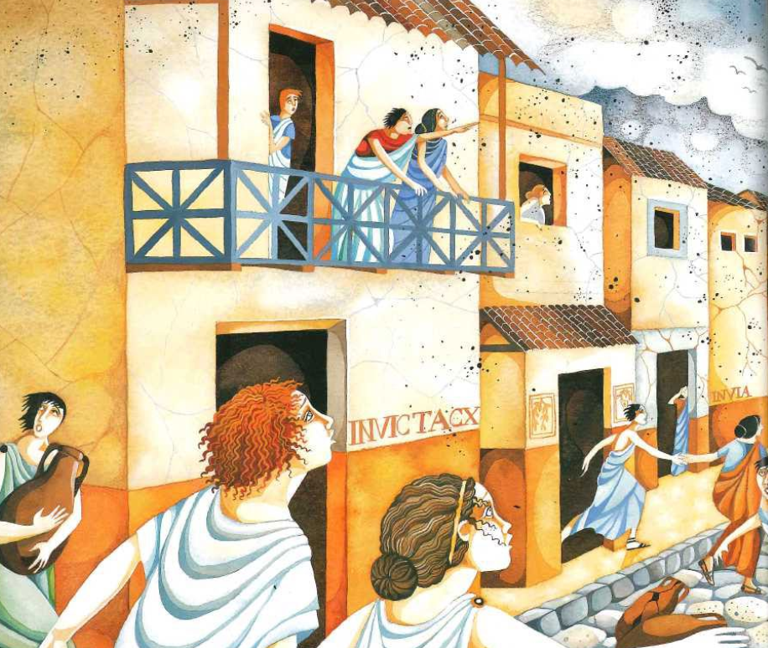
English
This week we have been writing a setting description of Pompeii.
Write sentences to describe the city of Pompeii when the volcano erupted and ash dominated the sky.
What would you see?
What would you hear?
What would you smell?
Maths
This week we have been developing our addition and subtraction skills
Solve the calculations
- 4625+27=
- 264-24=
- 8271-362=
- 4732+606=
Reading
Over the next few weeks, we will be exploring newspaper reports. Have a read of different newspapers and think about what information they provide to you as the reader.
Week | Task
1 | Research about Spartacus and find 5 intersting facts about him
2 | The Romans were known to make togas. Make a toga at home and take a photo. We’d love to see you wearing it!  Design your own toga. What theme would you give your toga?
3 | Romans had their own gods. Reasearch a Roman God and present what you have found in an exciting way. This can be a poster, a presentation or a film trailer
4 | Romans were known for their weapons. Research Roman weapons and make your own model version. Bring it back to school for us to put on display
5 | The Colosseum is a very famous Roman building. Reaseach the Colosseum and maake a model version of the building
6 | Make your own Roman Moasic artwork using cut paper, pasta shapes, seeds. Be creative as possible. Bring your artwork in so we can put on display
7 | Make a fact file about the Romans to teach Year 3 about them. What interesting information would they love to find out?
Project-This term our project is the Romans. Each week we have set you a project based on the Romans. Complete each task and bring in your pieces so we can put them on display for our pop up museum Expo at the end of term.

