Kestrels and Owls homework - Due in Tuesday 27th April 2021
This homework will be added to Google Drive and can be submitted via the drive.
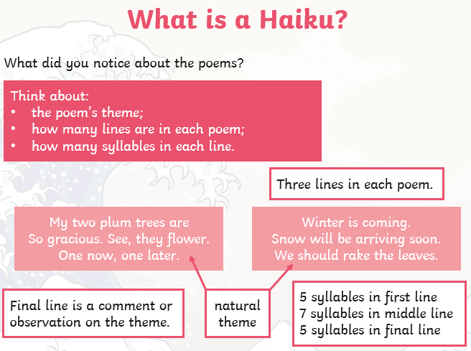
English
We have been reading and writing Haiku in class; here is a recap about the form.

Write a collection entitled

The Four Seasons.
Reading
We love to see what you are reading and enjoy your comments. Reading regularly (especially when you read aloud to an adult) builds your fluency and your vocabulary. It is important to read something you enjoy- so choose carefully!
Maths Task
Mrs Agbo and Miss Higginbottom’s group
21 x 32 | 147 ÷ 7 | 745 – 377 | 435 + 298
23 x 16 | 168 ÷ 8 | 861 – 599 | 2345 + 3789
14 x 12 | 252 ÷ 6 | 5242 – 189 | 4568 + 7645

Mrs Di Giorno’s group
We made a human place value chart to help us multiply and divide by 10/100
Write >, < or = to make the statements true. Make up three questions of your own.
Miss Rose’s group
Order these numbers from greatest to smallest
What is the value of the underlined digit?
51,027 | 63,490 | 32,189 | 8082 | 51,442 | 6687

5347 | 12,475 | 75,318 | 84,144 | 24,586 | 38,165

