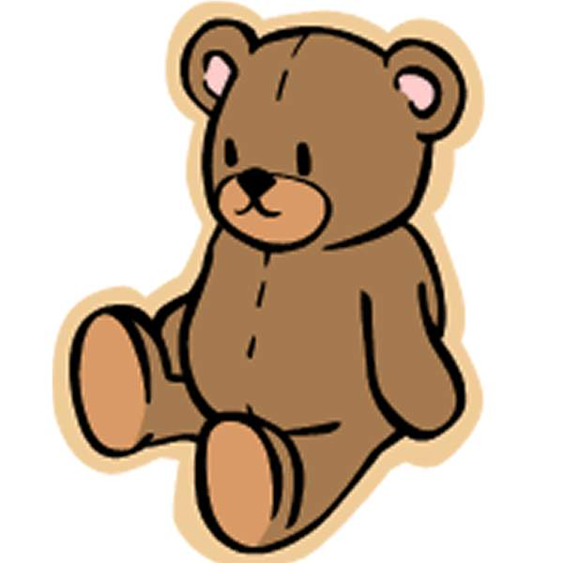

Home Science Activity – 5.2.16

As we have been learning about builders at school, our activity is an engineering one this week!

Using materials you have at home, can you build a chair for one of your teddies? Make sure he’s comfortable! You could use toys like Lego or building bricks, or you could recycle old boxes and bottles.

If you wanted to make it really challenging, see what you can do using just paper and sticky tape! (This might be a good challenge for big brothers and sisters)

Home Science Activity – 5.2.16

As we have been learning about builders at school, our activity is an engineering one this week!

Using materials you have at home, can you build a chair for one of your teddies? Make sure he’s comfortable! You could use toys like Lego or building bricks, or you could recycle old boxes and bottles.

If you wanted to make it really challenging, see what you can do using just paper and sticky tape! (This might be a good challenge for big brothers and sisters)