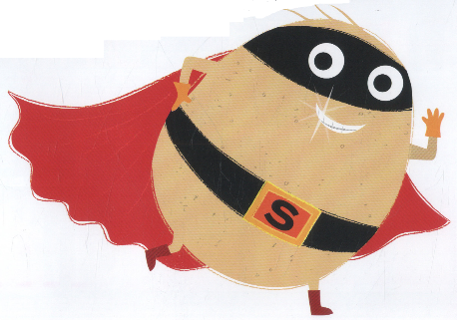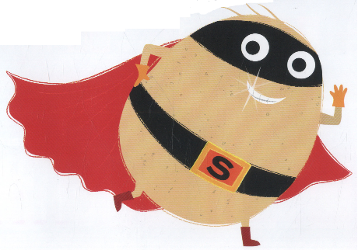

Home Science Activity – 6.5.16

Help Supertato!

The Evil Pea is up to mischief again! He keeps freezing Supertato’s friends! Can you do some research to help Supertato find the quickest way to melt ice?

First you’ll need to freeze some water in an ice cube tray or an ice bag.

Then when they have all frozen, break out the ice cubes and test out different ways of making them melt.

Can you put them into something that will help them melt quicker?

Where do you think is the best place in your house to melt the ice cubes?

Where does the ice go when it melts?

Don’t forget to write down your findings to send to Supertato!

Home Science Activity – 6.5.16

Help Supertato!

The Evil Pea is up to mischief again! He keeps freezing Supertato’s friends! Can you do some research to help Supertato find the quickest way to melt ice?

First you’ll need to freeze some water in an ice cube tray or an ice bag.

Then when they have all frozen, break out the ice cubes and test out different ways of making them melt.

Can you put them into something that will help them melt quicker?

Where do you think is the best place in your house to melt the ice cubes?

Where does the ice go when it melts?

Don’t forget to write down your findings to send to Supertato!