Home Science Activity – 27.5.16
Cooking with the Sun

Hopefully we’re going to get some nice weather this half term. This is a great activity for a sunny day!
You will need:
- Pizza box (other cuboid-shaped boxes will work, but a pizza box is easiest)
- Sharp scissors (grown-ups will have to be in charge of these!)
- Tin foil
- Sticky tape
- Cling film
- Black paper & newspaper (these are optional, but will make your oven work better)
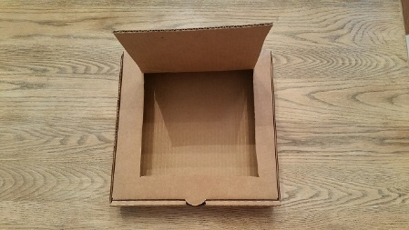
What to do:
- Use sharp scissors to cut a flap in the lid of the pizza box. Cut along three sides, leaving about an inch between the sides of the flap and the edges of the lid. Fold this flap out so that it stands up when the box lid is closed.
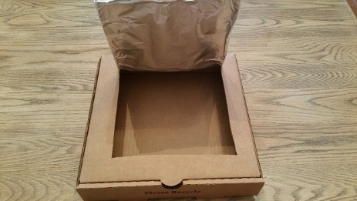

- Cover the inner side of the flap with tin foil so that it will reflect rays from the sun. To do this, tightly wrap foil around the flap, then tape it to the back, or outer side of the flap.
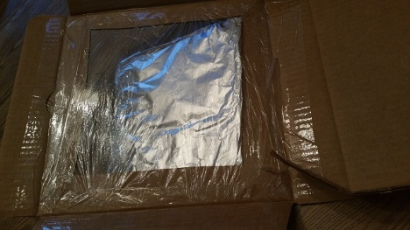
- Tape a square of clingflim on the inside of the box lid, making an airtight window for sunlight to enter the box. Make sure it is sealed with tape all the way round to protect your food from hungry minibeasts!

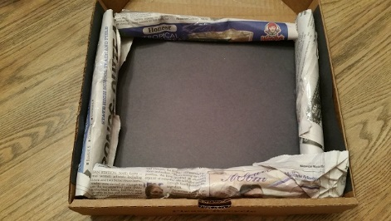
- Line the bottom of the box with black paper and roll up newspaper and place around the sides of your oven. This will help to insulate the oven (keep the heat in).

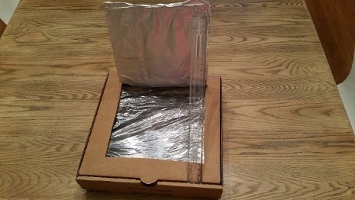
- The best hours to set up your solar oven are when the sun is high overhead—from 11 am to 3 pm. Take it outside to a sunny spot and adjust the flap until the most sunlight possible is reflecting off the tin foil and onto the plastic-covered window. Use a ruler to prop the flap at the right angle.

- When the food is ready to take out of the oven, ask a grown-up to help and make sure they use oven gloves – the food and plate could be very hot!

- You can make toast by buttering a slice of bread then letting the sun do the rest. Cheese on toast or cheesy nachos would work well too. Or if you want something sweet you could use your oven to melt marshmallows and chocolate buttons onto digestive biscuits!
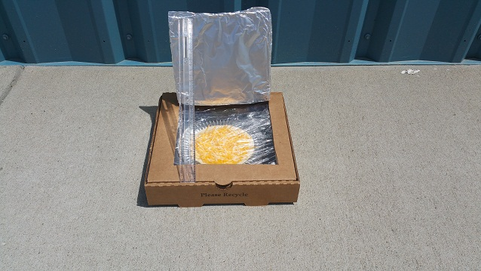

- If you have fun with your solar oven and want some more ideas for recipes scan the QR code with your phone, or click to:

http://www.going-green-challenge.com/solar-oven-recipes.html

