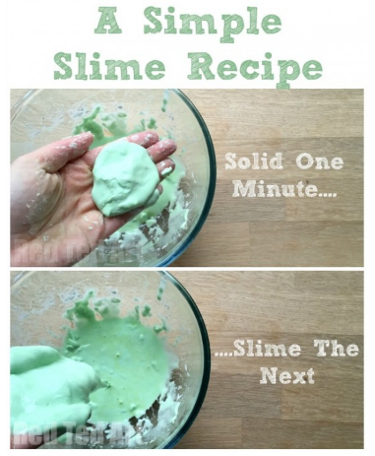

What’s going on?

The beautiful slime is known as a “Non-Newtonian fluid”. That just means it’s not really a liquid or a solid (it’s kind of both and kind of neither).

More Fun Please! - Experiment like a real scientist!

• Experiment with your slime. Try prodding it with your finger quickly and it will feel hard like a solid or if you pour it across your hands slowly it will feel like a liquid.

• Try making different coloured slimes.

• Try and make the ‘perfect slime’ with different amounts of water!

IMPORTANT! - When you are done with your slime, not for some time I’m sure! - Don’t pour it down the drain. The slime will separate back into cornflour and water and this can clog the pipes. Just wrap it in some paper and put it in the bin. (If you can bring yourself to!)

(Recipe & text from [www.redtedart.com](http://www.redtedart.com))

To make your slime you will need:

* A cup of cornflour
* UP TO one cup of water
* A few drops f food colouring (optional)

How to make your slime:

1. Place your cornflour and a few drops of food colouring into a bowl.
2. Gradually add your water and start mixing until you have a slimy/solid consistency. Make sure you don’t add the water too fast.

Done! Now play with your slime!

Home Science Activity – 20.5.16

Slime!

Today we have had fun making slime for our class treat! If you’d like to make some slime of your own at home, use the instructions below.

Remember, **don’t** put your slime down the sink when you’re finished, and **don’t** play with it near furniture or carpets. This will most likely result in some grumpy grown-ups in your house!