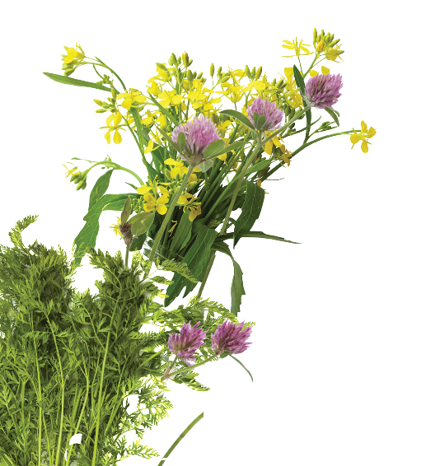
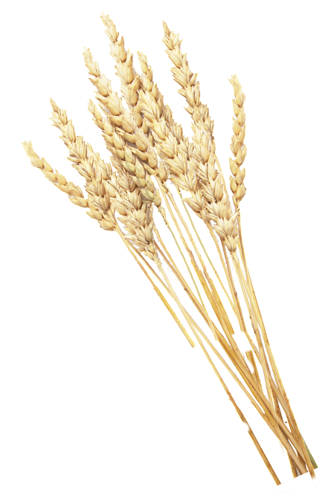
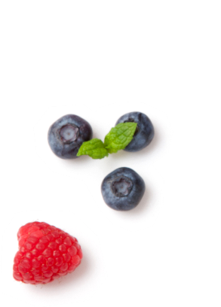
Sheep Resources

All the resources suggested here are free and available from the Countryside Classroom website.

Model Sheep

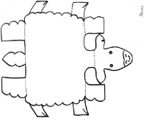
A simple model that allows children to decorate their own sheep. A chance to explore different sheep breeds or simply be creative.

https://www.countrysideclassroom.org.uk/resources/1552

A Sheep’s Year

A PowerPoint presentation with photos and text explaining what happens during a sheep's year and the lambing cycle.

https://www.countrysideclassroom.org.uk/resources/1551

Sheep and Wool
A booklet of activities collating many hands-on activities relating to sheep and wool (including easy spinning, weaving and felt making) alongside information to support farm visits at lambing time and throughout the year.
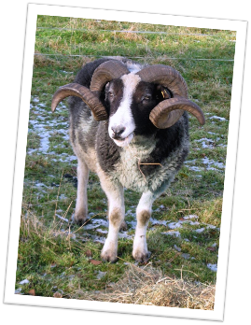
https://www.countrysideclassroom.org.uk/resources/1196

A home education version of this resource is also available
https://www.countrysideclassroom.org.uk/resources/1393

The Science of sheep

An e-booklet of ideas and activities for primary schools with a focus on sheep. https://www.countrysideclassroom.org.uk/resources/1309

A home education version of this resource is also available. https://www.countrysideclassroom.org.uk/resources/1393

Weaving with Sheep's Wool

A video resource explaining how to make a "Gods Eye" decoration and a friendship bracelet. Activities suitable for KS1 up, older students can develop design ideas and make more complex pieces. https://www.countrysideclassroom.org.uk/resources/1542

Felt Flowers from Sheep's Wool

How to make simple felt flowers that you can use to decorate hair bands, hats, brooches, bookmarks or whatever you like! A simple technique with a wow factor. Suitable for KS1 and above, older students will enjoy devolving the designs and creating more complex pieces. https://www.countrysideclassroom.org.uk/resources/1541

