Home Science Activity – 29.4.16
Super Secret Messages!
Your job this week is to create a secret message for a superhero!
You will need:
- One half of a lemon (make sure a grown up helps you to cut it!)
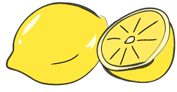
- Half a teaspoon of water
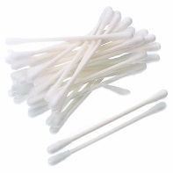
- Small bowl
- Spoon
- White paper
- Cotton buds
- A lamp with a lightbulb that gives off lots of heat, or another heat source, such as a radiator

What to do:
- Squeeze all the juice out of your lemon into the bowl and mix in the water with a spoon
- Think of a secret message for a superhero – you could write your name, a sentence, or do a picture
- Soak the end of a cotton bud in your mixture then use it to write your secret message on a piece of paper
- Wait a few minutes for the paper to dry. While you’re waiting you could turn on your lamp to give it time to heat up.
- When the paper is dry, get a grown up to help you hold it near to the bulb (be careful, it’ll be hot!) for a few minutes, but don’t let it get so hot it burns. Your secret message will appear!

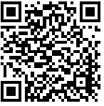
If you’re interested in the science behind this technique, scan the QR code for an explanation

