**Purple Mash - A ‘how to use it’ guide**

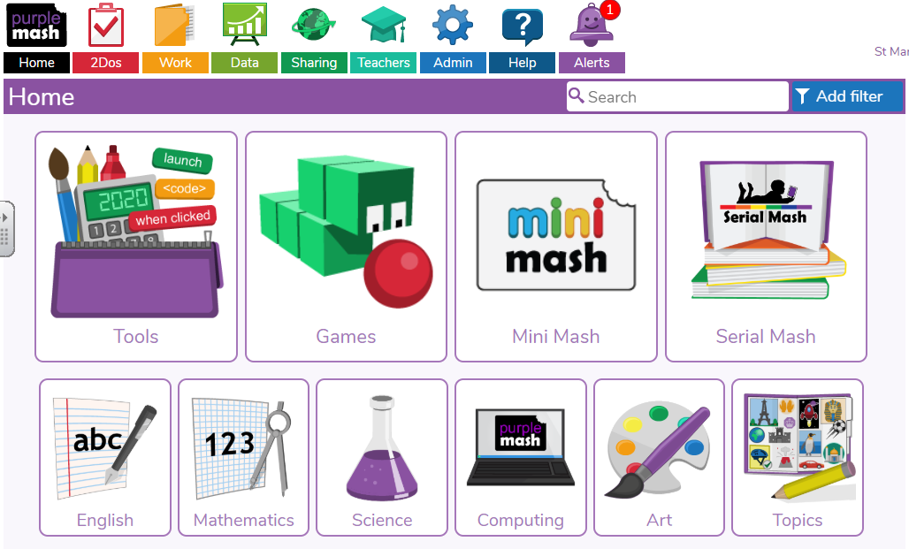

1

On the Purple mash home screen you should see a ‘tools’ button. Click on this.

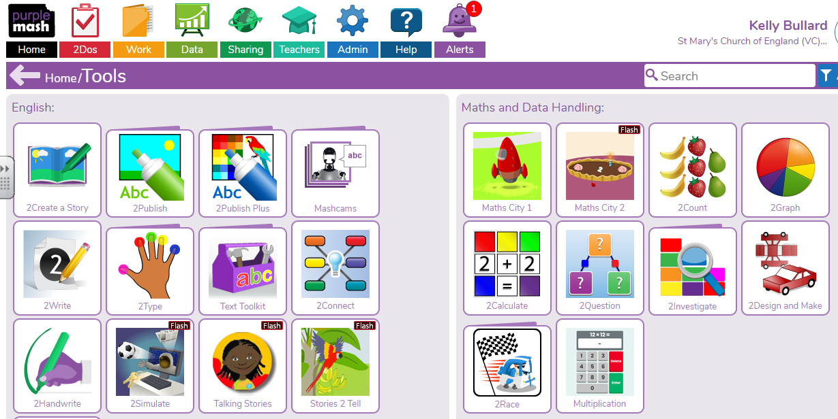

2

You will then see this page. You can scroll down to find different activities linked to different subject areas.

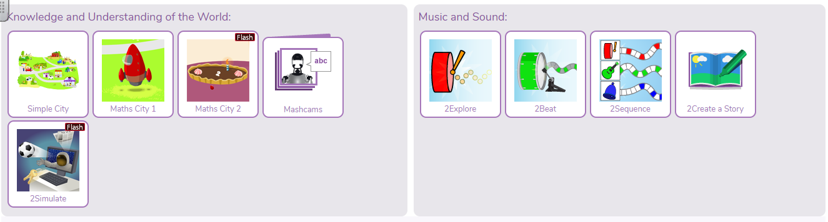**Music and Sound – 2Explore**

Click on the ‘2Explore’ button to create a tune.

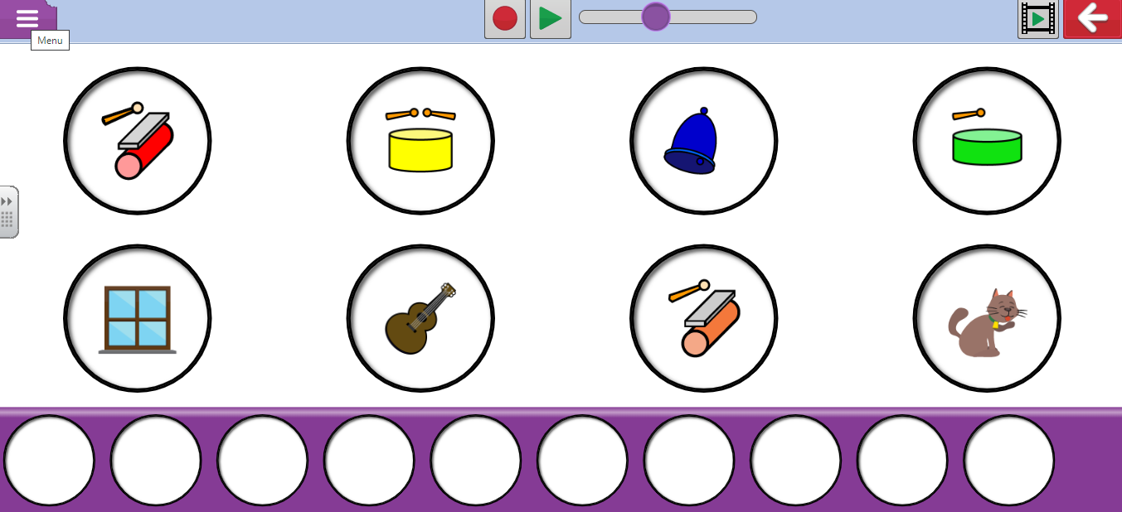

The button highlighted in red is a video demonstration of how to use this app. There is one of these on all apps to explain how to use each one.

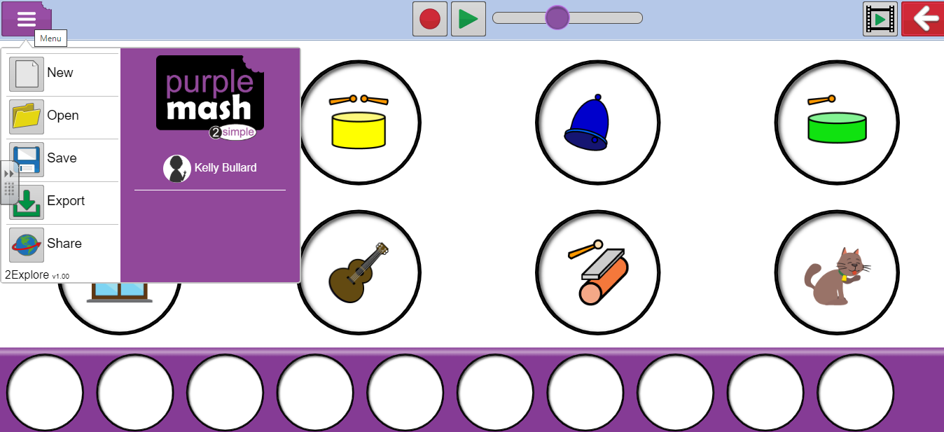

You can save your work by clicking the menu button and pressing save. I can then look at what you have been doing.