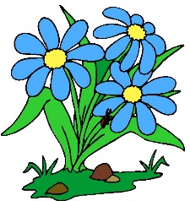

Home Science Activity – 1.7.16

Plants

We are learning all about plants at school, so your job for homework this week is to go on a plant hunt!

Can you find:

* A plant with leaves that aren’t green?
* A plant growing somewhere unusual, for example in a crack in the pavement or the walls of a house?
* A plant that is taller than you?
* A plant with flowers that are more than one colour?
* A plant with spikey leaves?
* A plant that smells nice?
* A plant that bees like?

You could record your findings with photos, drawings or writing, and we will look at what everyone found out during family time next week.

Happy hunting!

Home Science Activity – 1.7.16

Plants

We are learning all about plants at school, so your job for homework this week is to go on a plant hunt!

Can you find:

* A plant with leaves that aren’t green?
* A plant growing somewhere unusual, for example in a crack in the pavement or the walls of a house?
* A plant that is taller than you?
* A plant with flowers that are more than one colour?
* A plant with spikey leaves?
* A plant that smells nice?
* A plant that bees like?

You could record your findings with photos, drawings or writing, and we will look at what everyone found out during family time next week.

Happy hunting!