Home Science Activity – 22.1.16
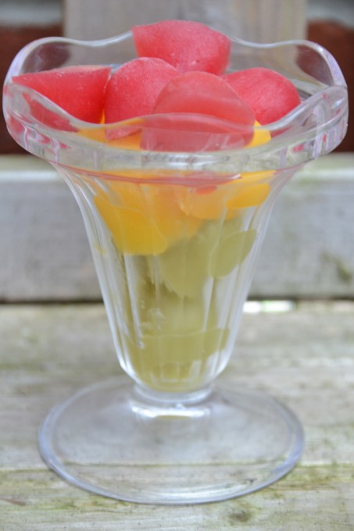
It’s been very cold lately and we’ve had lots
of fun smashing ice on the ground, so this
week’s Science activity is going to be a
chilly one!

Have a go at making your own slushy fruit
drink by freezing two or more fruit
juices/squashes, then leaving a combination
of your ice cubes out to melt. You could
even add in some food colouring to some to
make the colours a bit more interesting!

There are lots of possibilities with this activity, you could:
- Set up two or three glasses with the same number of ice cubes and lace them in different places to see which melts first
- See what colours you can make with different fruit juices
- See if the ice cubes melt faster if you stir them, or hold on to your glass

Top Tips!
Let the juice cubes melt a little before removing them from the ice cube tray. They will feel sticky to start with, because the ice is freezing to moisture in your fingers

