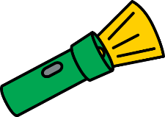

Home Science Activity – 4.3.16

Minibeast Shadows

First you need to find a place in your home where you can make shadows. This might be your bedroom or living room, or you could set up a torch or a phone to shine light at a wall. See if you can make some minibeast shadow shapes with your hands.

* Can you make a spider shape with eight legs?
* Can you make a long, thin caterpillar shape?
* Can you make a butterfly shape with big, wide wings?
* Can you make a rounded shape like a ladybird?
* What other ideas can you think of?

You could draw or photograph your shadows to show everyone at school what you have done.

Home Science Activity – 4.3.16

Minibeast Shadows

First you need to find a place in your home where you can make shadows. This might be your bedroom or living room, or you could set up a torch or a phone to shine light at a wall. See if you can make some minibeast shadow shapes with your hands.

* Can you make a spider shape with eight legs?
* Can you make a long, thin caterpillar shape?
* Can you make a butterfly shape with big, wide wings?
* Can you make a rounded shape like a ladybird?
* What other ideas can you think of?

You could draw or photograph your shadows to show everyone at school what you have done.