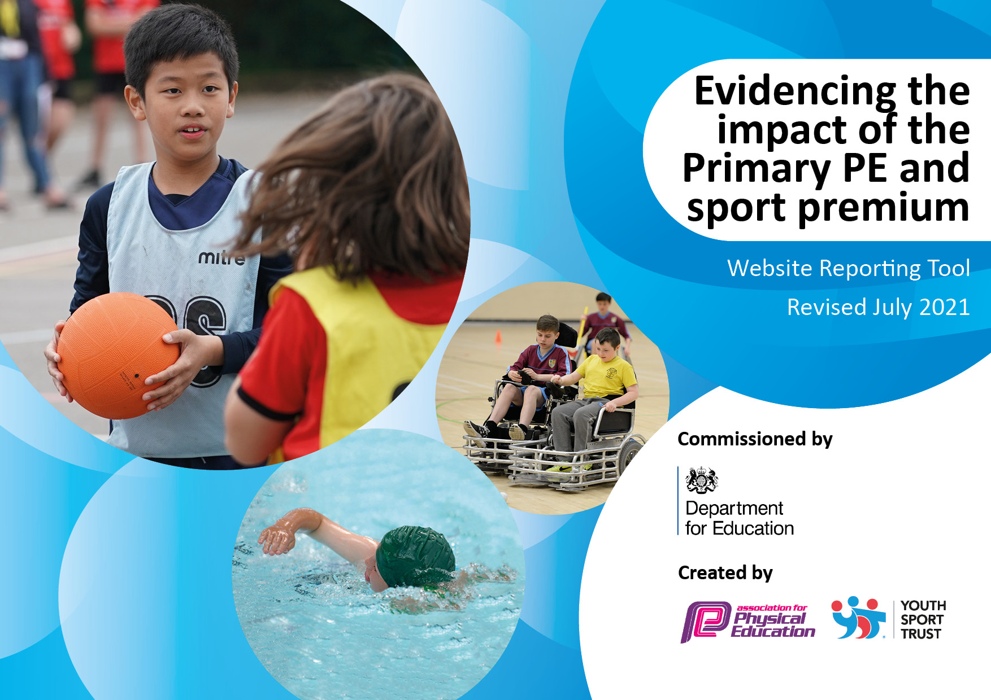
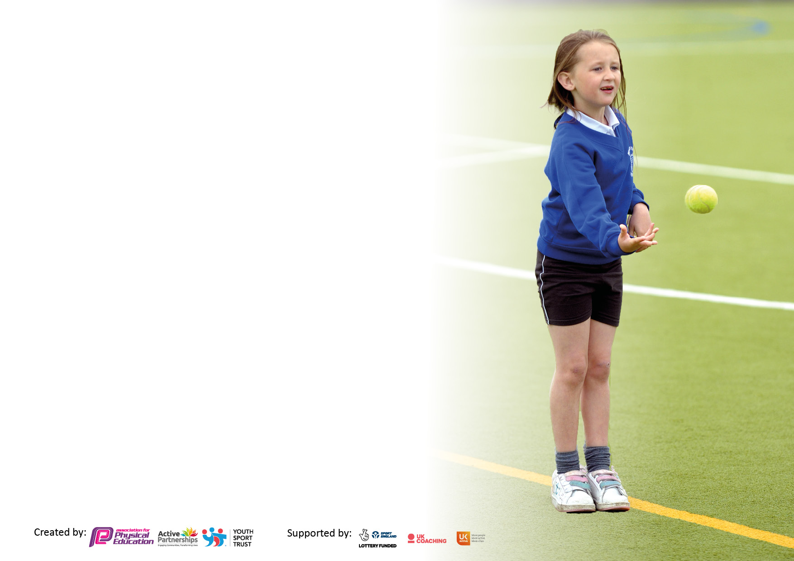

It is important that your grant is used effectively and based on school need. The Education Inspection Framework makes clear there will be a focus on ‘whether leaders and those responsible for governors all understand their respective roles and perform these in a way that enhances the effectiveness of the school’.

Under the Quality of Education Ofsted inspectors consider:
Intent - Curriculum design, coverage and appropriateness
Implementation - Curriculum delivery, Teaching (pedagogy) and Assessment
Impact - Attainment and progress

To assist schools with common transferable language this template has been developed to utilise the same three headings which should make your plans easily transferable between working documents.

Schools must use the funding to make additional and sustainable improvements to the quality of Physical Education, School Sport and Physical Activity (PESSPA) they offer. This means that you should use the Primary PE and sport premium to:

- Develop or add to the PESSPA activities that your school already offer
- Build capacity and capability within the school to ensure that improvements made now will benefit pupils joining the school in future years
- The Primary PE and sport premium should not be used to fund capital spend projects; the school’s budget should fund these.

Pleasevisitgov.ukfortherevisedDfEguidanceincludingthe5keyindicatorsacrosswhichschoolsshoulddemonstrate animprovement.Thisdocumentwillhelpyoutoreviewyourprovisionandtoreportyourspend.DfEencouragesschools to use this template as an effective way of meeting the reporting requirements of the Primary PE and sport premium.

We recommend you start by reflecting on the impact of current provision and reviewing the previous spend.

Schools are required to publish details of how they spend this funding, including any under-spend from 2019/2020, as well as on the impact it has on pupils’ PE and sport participation and attainment. All funding must be spent by 31st July 2022.

We recommend regularly updating the table and publishing it on your website throughout the year. This evidences your ongoing self-evaluation of how you are using the funding to secure maximum, sustainable impact. Final copy must be posted on your website by the end of the academic year and no later than the 31st July 2021. To see an example of how to complete the table please click HERE.

Details with regard to funding
Please complete the table below.

Total amount carried over from 2021/22 | £
Total amount allocated for 2022/23 | £
Total amount available for 2022/22 | £
Total amount spent for 2022/23 | £
How much (if any) do you intend to carry over from this total fund into 2023/24 | £
Swimming Data
Please report on your Swimming Data below.

Meeting national curriculum requirements for swimming and water safety.

N.B. Complete this section to your best ability. For example you might have practised safe self-rescue techniques on dry land which you can then transfer to the pool when school swimming restarts.
Due to exceptional circumstances priority should be given to ensuring that pupils can perform safe self rescue even if they do not fully meet the first two requirements of the NC programme of study
What percentage of your current Year 6 cohort swim competently, confidently and proficiently over a distance of at least 25 metres?  N.B. Even though your pupils may swim in another year please report on their attainment on leaving primary school at the end of the summer term 2020.  Please see note above | 79%
What percentage of your current Year 6 cohort use a range of strokes effectively [for example, front crawl, backstroke and breaststroke]?  Please see note above | 79%
What percentage of your current Year 6 cohort perform safe self-rescue in different water-based situations? | 85%
Schools can choose to use the Primary PE and sport premium to provide additional provision for swimming but this must be for activity over and above the national curriculum requirements. Have you used it in this way? | No

Action Plan and Budget Tracking
Capture your intended annual spend against the 5 key indicators. Clarify the success criteria and evidence of impact that you intend to measure to evaluate for pupils today and for the future.

Academic Year: 2021/22 | Total fund allocated: £ | Date Updated: July 2022
Key indicator 1: The engagement of all pupils in regular physical activity – Chief Medical Officers guidelines recommend that primary school pupils undertake at least 30 minutes of physical activity a day in school |  |  |  | Percentage of total allocation:
 |  |  |  | 27%
Intent | Implementation |  | Impact
Your school focus should be clear what you want the pupils to know and be able to do and about  what they need to learn and to  consolidate through practice: | Make sure your actions to achieve are linked to your intentions: | Funding allocated: | Evidence of impact: what do pupils now know and what can they now do? What has changed?: | Sustainability and suggested next steps:
Encourage children and families to be active outside of the school day.  To support children’s physical and mental wellbeing and stamina through active play times.  PE, sport and physical activity to be developed and promoted across the school as a key area of development.  Attend NOSSP festivals targeted at the least active and least confident | Afterschool club which includes physical activities for children to engage in such as football, rounders, multi-sports, games activities.  Football club run by Football Icon Academy coach.  Communicate the benefits of regular physical activity to parents through newsletters, parent meetings and the school website.  Promote clubs and activities in the local area through trial session in school such as LTA tennis, football, Chance to Shine cricket.  OPAL after school sessions aimed at engaging the whole family to stay and play in safe environment.  OPAL lunchtimes to be improved through phasing in different areas and additional resources. Encourage children to be active and creative in their play, working with other children from across the school to develop their communication skills as well as their physical and mental wellbeing.  Playground leaders (year 5 and 6) to be trained by NOSSP in the Autumn Term and then lead on activities and games at lunchtimes for all children to be involved in.  2 PE lessons per week for each pupil, using the Merton scheme of work to deliver the sessions. Teachers to be supported by the PE lead where appropriate.  Purchase new and additional sports equipment to support PE sessions and clubs and replace and equipment that needs updating.  Purchase new gymnastic equipment including mats, agility tables, and benches.  Commitment to NOSSP sports events across the year and across all age groups. Ensure all children are offered the opportunity to attend a sports festivals – KS2 children a variety of events such as tag rugby, netball, rounders, cricket, football and KS1 multi-skills festival.  Attend the Y3/4 and Y5/6 orienteering festivals and year 3/4 rounders festival which are aimed at children who are least confident and least active. | Additional staffing and coaching hours  £3500  Purchase of storage for equipment £2500  NOSSP affiliation and cover for training management time and resources £3500  £3000  NOSSP affiliation (£2000)  NOSSP affiliation (£2000) | Children have been more engaged with after school clubs with a range of children from across the school taking part.  More children engaged with football, two school football teams – girls and boys competing in a Banbury schools league competition. Children who took part in the club has also signed up for football clubs in the community.  Parental engagement in school sports has increased with an increased number of parents watching sports events such as football matches and sports day.  More children have engaged with clubs and sports in the community as well as sessions that are provided in school. Children have a better understanding of the variety of sports on offer to them.  Families are able to be active outside of the school day and are offered ideas and inspiration of how to be more active when outside.  Children have had calmer and more active lunchtimes through the OPAL project. They work together and take responsibility for tidying up and working as a team. Children come back into class calmer and ready for learning.  Year 5 and 6 children developed leadership skills and successfully led a variety of games and activities which other children from across the school, including EYFS, took part in.  PE lessons are appropriate to the level of development for our children and adapted appropriately, as many children over lockdown were not physical active.  Staff have been able to deliver PE sessions using the correct equipment to support their delivery. Clubs such as tag rugby club have been able to happen successfully with sufficient equipment.  Children have been able to take part in competitive and non-competitive sports festivals and have developed their understanding of why we do PE and play different sports. They can use the skills learnt in PE lessons in practise at events.  Children who attended enjoyed the festival and increased confidence to take part in sports. | Continue next year with more external sports coming in to deliver after school session, particular in areas where staff do not have expertise such as dance and gymnastics.  Continue to build on this by introducing different sports and opportunities for parents to be actively involved.  Continue to use local clubs and sports providers to deliver sessions in school next year, focus on dance and gymnastics.  Continue to promote the use of OPAL stay and play sessions to the wider community to reach more families, particularly those that are more vulnerable with limited access to outside space.  Continue to grow and develop existing areas with new areas being phased in throughout the year. Promote the OPAL lunchtimes again with parents with a request for continued donations for equipment and resources from parents and the local community to support this project.  Playground leaders to be in place next year with the current year 5s who have been trained supporting their peers in becoming playground leaders. Incorporate their role into OPAL lunchtimes and supporting children in their play.  Develop new PE and sports awards to be presented each week in our celebration worship to promote the sports values such as team work, resilience and compassion.  Stock take of current sports equipment and replace anything that needs replacing to support the delivery of the PE curriculum.  Investment in a specialist PE coach to support teacher CPD within PE.  Continued commitment to NOSSP sports festival throughout the year.  Official electronic tracker of children who have attended the events.  Continue to attend NOSSP festivals targeted at the least active and least confident.
Key indicator 2: The profile of PESSPA being raised across the school as a tool for whole school improvement |  |  |  | Percentage of total allocation:
 |  |  |  | 10%
Intent | Implementation |  | Impact
Your school focus should be clear what you want the pupils to know and be able to do and about  what they need to learn and to  consolidate through practice: | Make sure your actions to achieve are linked to your intentions: | Funding allocated: | Evidence of impact: what do pupils now know and what can they now do? What has changed?: | Sustainability and suggested next steps:
Celebrate physical activity, with a focus on sports values.  Engage children in sports competitions across the school including interschool with NOSSP and Inter house competitions within school.  Use Physical Education to develop the child as a whole, including life skills with links to our school values. | Celebration worships to celebrate sports success including swimming certificates, interschool competitions with NOSSP, and success in PE lessons.  Four children from year 4 appointed sports captains to raise the profile of sport throughout the school (especially during sporting events)  Children to support during sports activities (Sports Day, Sport relief) and encourage active activities during break and lunchtimes through playground leaders and OPAL.  All children to take part in at least one NOSSP event during the year. Events including; multi-skills (year 1 and 2), football, rounders, quad kids, cross country. NOSSP values certificates to be awarded in celebration worships.  Sports day – inter house competition throughout the day with parents invited to attend the afternoon races. Sports values awards to be presented in celebration worship as well as the sports day trophy.  Cojo’s to be continued as part of our whole school curriculum offer to increase confidence and communication while being active and working as a team. All classes to be allocated a dedicated time each week to complete.  Focus on personal best challenges through NOSSP affiliation and through PE lessons to raise the profile of fitness and wellbeing. | NOSSP affiliation (£2000)  £2500 | Pupils show enthusiasm towards sports and it is viewed as an important part of the curriculum. Children support each other and show compassion to others who have been successful.  Pupils are more aware of competitions and engagement in competitions has increased. Pupils are more aware of other sports that they can outside of school as well.  Children are more aware of a range of sports and show enthusiasm towards learning and taking part in competitive sports in PE sessions, afterschool clubs and competitions.  Children, staff and families are invested in house sports as they all belong to a house. Key school games sports values are demonstrated, team work, resilience, compassion, respect, determination.  Teachers are using Cojos to support both physical and mental development. Cojo missions are linked to projects during each term so that it relates to current learning. Children are able to transfer their team work and communication skills to OPAL lunchtimes and sports events. | Continue to celebrate sports and PE in the same way through celebration worships. Introduce sports value certificates for PE sessions each week in addition to the school awards.  Continue to take part in inter school competitions through the NOSSP partnership.  Increase inter house competitions in school with a variety of sports competitions throughout the year.  Continue to use Cojos as part of our curriculum.  Linking life skills, school values and our school vision to PE lessons with an emphasis on transforming rather than ‘being the best’.

Key indicator 3: Increased confidence, knowledge and skills of all staff in teaching PE and sport |  |  |  | Percentage of total allocation:
 |  |  |  | 32%
Intent | Implementation |  | Impact
Your school focus should be clear | Make sure your actions to | Funding  allocated: | Evidence of impact: what do pupils now know and what can they now do? What has changed? | Sustainability and suggested
what you want the pupils to know  and be able to do and about  what they need to learn and to  consolidate through practice: | achieve are linked to your  intentions: |  |  | next steps:
Develop the teaching of PE and ensure a wide range of skills are being covered.  Ensure that PE is being assessed in meaningful way.  Ensure that staff have access to quality PE resources to enable them to deliver high quality sessions.  Use the YST Quality Mark Award to complete an online self-review to audit our PE provision and sport. | Staff that are going swimming to have refresher training through NOSSP.  New staff to school to be swim trained.  CPD to support the delivery of PE through coaches for tennis (LTA), cricket (Chance to shine) and gymnastics (ODST/NOSSP to support). Staff to watch the delivery of a session and be supported through content ideas, games and structure of these sports. Gymnastic CPD for staff as this is an area highlighted by staff as being an area in PE to develop.  Motion house dance company staff CDP to support the teaching, delivery and enthusiasm around dance in the curriculum.  Premier League Primary Stars programme to be delivered through Oxford United. Coming to school for one day a week for 12 weeks to support the teaching of PE, confidence in reading and PSHE sessions.  All classes using PE folders with specific tracking sheets in to monitor attainment in PE across all year groups.  Continued investment in PE equipment including gymnastic equipment – benches, mats and agility tables and replenishing stocks when needed e.g. tennis balls and beanbags.  Complete the form with and use recommendations and areas for development to support whole school development of PE. | Oxford United  Merton  NOSSP affiliation | Children’s progress in swimming has increased with many children across years 6, 5 and 4 achieving their 25 meters.  Staff have felt better supported in the delivery of PE and by having external agencies come in they have been exposed to a variety of delivery methods and games.  Year 2 teacher was supported to deliver high quality PE lessons in the Autumn Term through engagement with Oxford United in the Community.  Staff have a better awareness of the level of development of each child in PE through accurate assessment in each of the areas of PE.  Staff have continued access to quality sports equipment which they can access for each session. After school club also has access to this equipment to ensure quality delivery of sports sessions.  Bronze quality mark awarded reflecting that we are aware of areas for continued improvement and development. Commitment to promoting and engaging children in sport. | Ensure relevant staff are swim trained and have refresher training where needed.  Continue to focus on developing gymnastics and dance as key areas of the PE curriculum.  Use of an external sports coach to deliver and support teaching of games activities and athletics through Football Icon Academy.  .  Ensure this is continued through regular monitoring. PE folders to remain in place as good evidence of attainment tracking.  Replenish equipment where necessary to sustain high quality resources for lessons.  Use this to inform our development plan and it is a working document to be reflected on.
Key indicator 4: Broader experience of a range of sports and activities offered to all pupils |  |  |  | Percentage of total allocation:
 |  |  |  | 16%
Intent | Implementation |  | Impact
Your school focus should be clear | Make sure your actions to | Funding | Evidence of impact: what do | Sustainability and suggested
what you want the pupils to know | achieve are linked to your | allocated: | pupils now know and what | next steps:
and be able to do and about | intentions: |  | can they now do? What has
what they need to learn and to |  |  | changed?:
consolidate through practice:
Year 1 and year 2 children to attend the multi-sports event at Wykham academy to engage younger children in sports competitions and events.  Year 6 top-up swimming to support children in achieving their 25m award due to the impact of Covid.  Football club offered to KS2 children and a girls and boys football team to compete in a Banbury schools league  Cherwell Activators after school club offered over 3 terms in the year for all year groups.  Olympic Athlete in school for the day to showcase their sport to whole school. | Register for event through NOSSP.  Additional 30minute session at Spice Ball Leisure Centre each week for 12 weeks for the children in year 6 who need extra session to achieve their 25m.  Football Icon Academy coach to run the after school football club for years 4, 5 and 6.  KB (FA Level 1 qualified football coach) to run lunchtime football club for the two school teams.  Activators to run multi-sports sessions for a range of children to give them the opportunity to experience fun sports and games and increase active levels in children outside of the school day.  All children took part in a sponsored sport session as part of the athletes visit. Whole school attended an assembly about the athletes sport and how she got there. | NOSSP affiliation  NOSSP affiliation  Football Icon Academy coach  Activator sessions | All children took part from year 1 and enjoyed the event. Exposed to a variety of sports activities and were able to work as a team.  More children supported to achieve their 25m as well as children who could not swim at all achieving their 5 and 10m awards. These sessions enable children to develop confidence and enthusiasm for swimming.  Pupils have had the opportunity to play as a team against other schools. For our children this is a big opportunity as they do not attend football clubs outside of school.  Pupils engaged with the session well and enjoyed taking part in a range of games and activities.  Pupils were exposed to an Olympic sport which is not normally played in school. Children responded well and wanted to engage in more badminton activities. | Continue attendance at the year 1 multi-skills event with NOSSP.  These sessions were offered as part of the Covid recovery offer from NOSSP.  Continue with regular swimming sessions for year 4, 5 and 6.  Continue with football club next year and offer to KS1.  Continue the Banbury schools football league next year through NOSSP – Discuss at network meeting in the Autumn term. Discuss other sports leagues and arranging more friendly matches with local schools increase broader experience of sports.  Continue to book activator sessions next year – support parents in their awareness of the You Move programme.  Organise for a range of different athletes and clubs to showcase their sports to children with interactive sessions.

Key indicator 5: Increased participation in competitive sport |  |  |  | Percentage of total allocation:
 |  |  |  | 11%
Intent | Implementation |  | Impact
Your school focus should be clear | Make sure your actions to | Funding | Evidence of impact: what do | Sustainability and suggested
what you want the pupils to know | achieve are linked to your | allocated: | pupils now know and what | next steps:
and be able to do and about | intentions: |  | can they now do? What has
what they need to learn and to |  |  | changed?:
consolidate through practice:
Children to participate in inter-school competitions  Children to participate in intra-school competitions focusing on the school games sports values  All children to take part in sports day.  Take part in the U11 Banbury Primary Schools Football League | Children across the school to take part in NOSSP events competing against other schools; quad kids, cross country, football, rounders, cricket, handball, athletics, netball.  Organise regular small competitions for children to compete in houses linked to PE lessons.  Fun competitions such as dodgeball.  Plan and organise a sports day which allows all children to take part. In classes in the morning competing for their houses. Races in the afternoon, children to be in houses. Relay race introduced this year.  A boy’s football team and girls football team to be introduced to take part in a school’s football league where there will be a semi-final and final across the schools to decide to winners. Lunchtime club to be provided by KB to support the teams and encourage enjoyment and enthusiasm as well as developing football skills and team work.  Purchase shin pads and extra equipment kit where necessary. | NOSSP affiliation  NOSSP affiliation | All children in KS1 and KS2 have taken part in at least one NOSSP event.  Our teams are more competitive and understand the rules of a range of different sports.  Children were able to apply the skills they had learnt in PE sessions to a competitive, fun competition to earn points for their houses. Children displayed the sports values and were rewarded with certificates.  The school was able to come together to celebrate sports day. Children were motivated to achieve their personal best in different races and events in the morning. All children who participated in the relay race enjoyed it.  All children in both teams enjoyed taking part in the league and playing competitive matches against other school. The girls team came second in the B league and progressed to the semi-final. Lost the semi-final on penalties but the team showed great team spirit and all the sports values. Engaged all parents and staff in the matches, with most watching all home matches and most parents watching away matches. Other children in school keen to join the football teams as a result of the football league. | Invest in affiliation to NOSSP for the academic year 2022/2023 for sustained accessed to inter-school competitions and access to level 2 and 3 school games competitions, events and festivals.  Ensure more of these are organised throughout the year to engage more children in fun competitions to apply their PE skills. House captains and sports captains to be part of organisation.  Consider other races and structure of day.  Continue this next year – discuss at next NOSSP network meeting. Encourage more matches in different sports against other schools to raise the profile of competitive sports.  Invest in a new football kit.

Signed off by
Head Teacher: | V E Woods
Date: | June 2023
Subject Leader: | Kelly Bullard
Date: | June 2023
Governor: | M Thompson
Date: | July 2023

