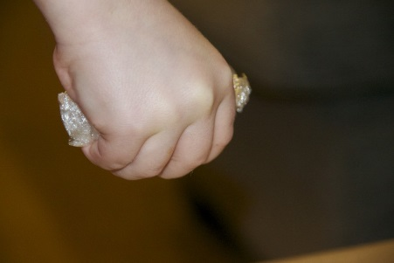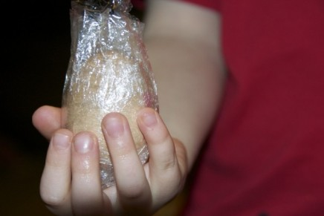

Home Science Activity – 24.3.16

The Unbreakable Egg!

As it’s Easter, we thought we’d do some egg-related Science this week!

We all know eggs are fragile

don’t we? Well here’s a bit of

Science magic! Wrap an egg in

clingfilm, then squeeze it in your

hand as hard as you can. It just won’t break! Mrs Horan even tried this at home to make sure, and just couldn’t break her egg! (You can try it without the clingfilm if you’re feeling extra brave…)

Why won’t it break? Even

though the shell is fragile, the

shape of an egg is very

strong. If pressure is applied

evenly the shell will not break.

Feeling inspired to do some more eggy Science? Scan the QR

code for many more egg experiments!

Home Science Activity – 24.3.16

The Unbreakable Egg!

As it’s Easter, we thought we’d do some egg-related Science this week!

We all know eggs are fragile

don’t we? Well here’s a bit of

Science magic! Wrap an egg in

clingfilm, then squeeze it in your

hand as hard as you can. It just won’t break! Mrs Horan even tried this at home to make sure, and just couldn’t break her egg! (You can try it without the clingfilm if you’re feeling extra brave…)

Why won’t it break? Even

though the shell is fragile, the

shape of an egg is very

strong. If pressure is applied

evenly the shell will not break.

Feeling inspired to do some more eggy Science? Scan the QR

code for many more egg experiments!