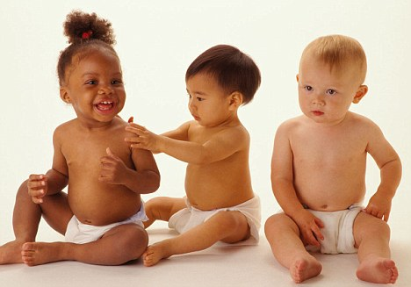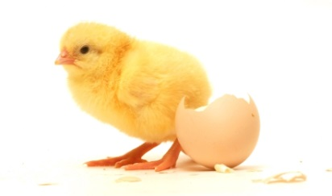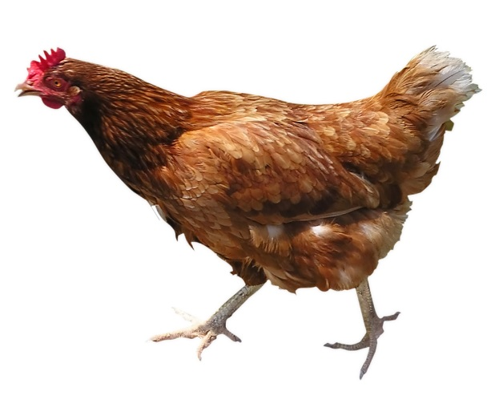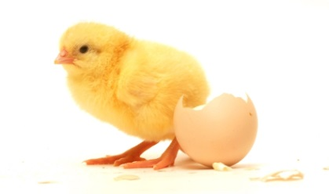

Home Science Activity – 22.4.16

Growing Up

Soon our eggs are going to hatch! When the chicks come out, they will look different to grown-up chickens. Can you see any differences?

See if you can find some pictures of you or people in your family when they were babies. How have you changed? What has stayed the same?

Home Science Activity – 22.4.16

Growing Up

Soon our eggs are going to hatch! When the chicks come out, they will look different to grown-up chickens. Can you see any differences?

See if you can find some pictures of you or people in your family when they were babies. How have you changed? What has stayed the same?