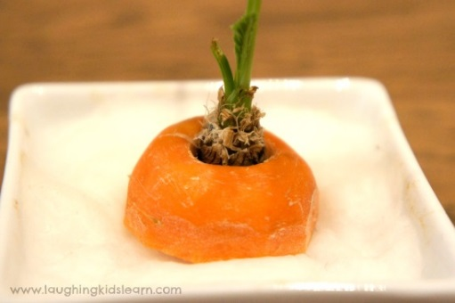

Home Science Activity – 8.7.16

Grow a Carrot Top

This week your challenge is to grow something using tea time leftovers!

You will need:

* Carrot top (needs to have some root growth remaining on the top)
* Shallow dish or saucer
* Cotton wool balls

What to do:

This one’s really simple.

All you need to do is add a layer of cotton wool balls to the dish and place the carrot top on top. Add enough water to the cotton balls so that they are damp but not flooded with water, then place your dish in a sunny spot like a windowsill. Make sure to check that your cotton balls stay damp throughout your growing period.

It will take a little while to get going, but once your carrot top starts it will grow quite quickly.

If you catch the veggie-growing bug, leeks, spring onions and garlic can all be easily regrown from leftovers.

Home Science Activity – 8.7.16

Grow a Carrot Top

This week your challenge is to grow something using tea time leftovers!

You will need:

* Carrot top (needs to have some root growth remaining on the top)
* Shallow dish or saucer
* Cotton wool balls

What to do:

This one’s really simple.

All you need to do is add a layer of cotton wool balls to the dish and place the carrot top on top. Add enough water to the cotton balls so that they are damp but not flooded with water, then place your dish in a sunny spot like a windowsill. Make sure to check that your cotton balls stay damp throughout your growing period.

It will take a little while to get going, but once your carrot top starts it will grow quite quickly.

If you catch the veggie-growing bug, leeks, spring onions and garlic can all be easily regrown from leftovers.