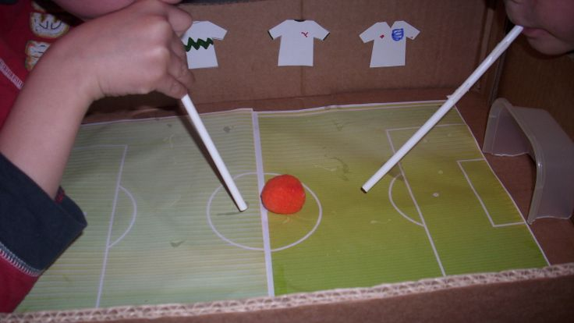

Home Science Activity – 17.6.16

Blow Football

Euro 2016 is here! To celebrate, this week we are exploring some basic forces ideas with a game of blow football. This is really easy to set up. You will need:

* A ball – this could be a ping-pong ball, a small pom-pom, a ball of rolled up tinfoil, or anything else that is small, round and light
* A drinking straw for each player
* Two goals. You could make these out of cardboard, or something like butter tubs or Tupperware boxes will do

And here’s how to play:

Place a border round the pitch (books might be suitable) to stop the ball going outside the field of play. Then put the ball in the middle of the pitch and blow! If you get the ball in the opponent’s goal you have scored. First to five goals wins.

The only rule is that you’re not allowed to touch the ball while it is in play - with hands, straws or anything else. If you do, the opponent gets a penalty!

If you’re feeling creative, you could make a pitch out of some green paper and a cardboard box.

Home Science Activity – 17.6.16

Blow Football

Euro 2016 is here! To celebrate, this week we are exploring some basic forces ideas with a game of blow football. This is really easy to set up. You will need:

* A ball – this could be a ping-pong ball, a small pom-pom, a ball of rolled up tinfoil, or anything else that is small, round and light
* A drinking straw for each player
* Two goals. You could make these out of cardboard, or something like butter tubs or Tupperware boxes will do

And here’s how to play:

Place a border round the pitch (books might be suitable) to stop the ball going outside the field of play. Then put the ball in the middle of the pitch and blow! If you get the ball in the opponent’s goal you have scored. First to five goals wins.

The only rule is that you’re not allowed to touch the ball while it is in play - with hands, straws or anything else. If you do, the opponent gets a penalty!

If you’re feeling creative, you could make a pitch out of some green paper and a cardboard box.