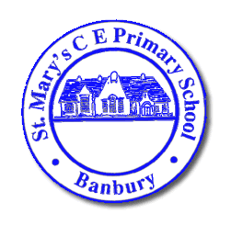  Headteacher: Mrs Victoria Woods | St Mary’s C E Primary School  Southam Road  BANBURY  Oxfordshire  OX16 2EG  Telephone: 01295 263026  Email:office@banburystmarysschool.co.uk  Web: www.banburystmarysschool.co.uk
Wake Up Shake Up Breakfast Club
Autumn 2020

Breakfast Club will be reopening from Monday 7th September at 7.30am in the Flight House.

Breakfast Club is run as an additional service to school and as such has its own costs for staffing, provisions and cleaning. As such we have to make sure that costs are covered and through the last 2 years these costs have consistently been greater than the income received. Therefore we have reviewed the payment structure in order to try to ensure that the provision remains viable since we can not subsidise the costs of Breakfast Club from the main school budget.

The new charges will be;

First child | £3.50 per day | £17.50/week
Second Child | £3.50 per day | £17.50/week
Third and subsequent child | £1.00 each child per day | £5.00/week per child
Children eligible for Means tested Free School Meals | £1.00 per child per day | £5.00/week per child

In order to manage the staffing, procurement of food and cleaning regimes required to enable Breakfast Club to operate safely in the post COVID period, we have to operate a strict booking ahead policy for places at Breakfast club. Places must be booked by 3.30pm on the Friday before the week care is needed. Of course regular booking patterns can be made for a whole term. If you have a dire emergency need for care, we will always try to be flexible, but please understand that ad hoc usage of breakfast club can no longer happen.

Booking forms for Breakfast Club can be downloaded from the website or from the office. Payment can be made through Parentmail.

Mrs Ahmed or Mrs Bucket in the Office will be happy to help you with anything else about Breakfast Club.

Victoria Woods.
Headteacher.

