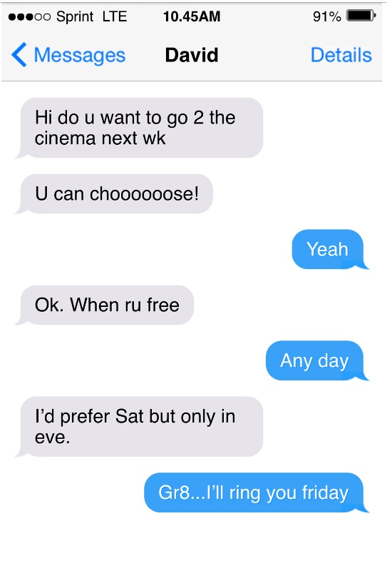
Kestrels homework - Due in Tuesday 29th September 2020
English Task
Informal and informal writing
Turn this text message into a more formal conversation between David and Faye.
Maths Task
This week we have been practising our rounding skills. Can you round these numbers to the nearest 10, 100 and 1000
 | Mild | Spicy | Hot
 | Round to the nearest 10 | Round to the nearest 100 | Round to the nearest 1000
1321
4567
7842
8759
6755

Reading
You should be reading a minimum of four times a week. Make sure you write a comment in your reading record each time. Try looking for vocabulary that has a formal tone or an informal tone and look at the context of the sentence.
E.g. She yelled, “See ya!” and dashed across the road.
Project Task Geography
Use the country names and bodies of the water below to help you:
- Northern Ireland
- Wales
- Scotland
- England
- Irish sea
- North sea
- Atlantic ocean
- English channel

Can you remember what the flags that represent each country look like?

